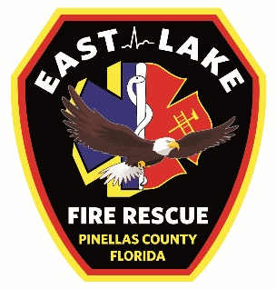
EAST LAKE TARPON
BOARD OF
FIRE COMMISSIONERS
Randy Burr
Jim Dalrymple
Kevin Kenney
Tom McQueen
David J. Root

SPECIAL FIRE CONTROL DISTRICT
3375 Tarpon Lake Blvd.
Palm Harbor, FL 34685
727-784-8668 fax: 727-474-5830
www.elfr.org

Accident/Damage Report Form
To be completed by the employee immediately following any incident that resulted in injury or property damage and submitted via email to the Deputy Chief through the COC.

Personnel/Vehicle | Accident Occurred: | Roadway: Check all that apply |  | Weather | Type of Loss
Driver: | ☐ At station | ☐ Straight | ☐ 4-lane | ☐ Clear | ☐ Personal Injury
 | ☐ Responding to emergency | ☐ Curve | ☐ Divided | ☐ Rain | ☐ Property Damage
Vehicle involved: | ☐At emergency scene | ☐ Dry | ☐ Lanes Marked | ☐ Fog | ☐ Vehicle Damage
 | ☐ Returning from emergency | ☐ Wet | ☐ Lanes Unmarked | ☐ Other
Apparatus Officer: | ☐ Training | ☐ Oily | ☐ Other
 | ☐ Other | ☐ 2-lane
Additional Personnel involved: |  | ☐ 3-lane

The following sections will be completed for all incidents:
Date of incident: | Approximate time of incident: (24 hour)
Location of incident (be specific as to where, what intersection or what location, etc.):

Insert or Attach digital photos of the incident location and detailed pictures of the vehicle damage:

Detailed description of accident:

What acts, failures to act and/or conditions contributed most directly to this accident? (Immediate Cause)

What are the basic or fundamental reasons for the existence of these acts and/or conditions? (Fundamental Cause)

What action has or will be taken to prevent recurrence?

Safety Supervisor's Comments

Driver's review and approval of information: |  |  | Date:
Supervisor's review: |  |  | Date:
Safety Supervisor's review: |  |  | Date:
Safety Committee use only
Reviewed by (list names): |  | Date:
Recommended actions:

