EAST LAKE TARPON
BOARD OF FIRE COMMISSIONERS Randy Burr Jim Dalrymple Kevin Kenney Tom McQueen David J. Root

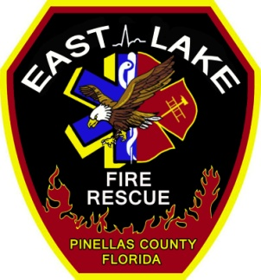
SPECIAL FIRE CONTROL DISTRICT
3375 Tarpon Lake Blvd.
Palm Harbor, FL 34685
727-784-8668 fax: 727-474-5830
www.elfr.org

MONTHLY FACILITY SAFETY INSPECTION
Month: Station: Members present:

ELECTRICAL/GAS:
Generator:
Leaks
Gauges
Wiring
Fluids
Block Heater
Test Cycle
General Appearance

Additional Comments:

Bay Doors:
Note any concerns:
Breakers and Outlets: Check all outlets. Test GFI’s, check to see if any outlet is worn or not functioning.
Water Heater: Any leaks? Does water get hot in appropriate time? General maintenance needed (flushing)?
Air Conditioner: Performing properly? Last scheduled maintenance (filters)?
Dryer: Is dryer drying clothes? Clean out vent twice a year.
Oven: Heating properly?
Check all of the following to see if operating properly:
- Lights
- Refrigerator
- Microwave
- Ceiling fans
- Phones
- Computers
- Coffee makers
- Grills
- Televisions

List any deficiencies found:

Plumbing:
- Toilets and urinals are working appropriately and not leaking?
- Spigots are easy to turn and not leaking?
- Faucets are functioning properly with no leaking.
- No leaks from the following; dishwasher, washer machine, and water softener connections? No leaks from under sinks or from disposals?
- Ice machine is working properly.
Please record any findings:

Miscellaneous Housekeeping: Interior
Check flooring (carpet or tile), walls, ceilings, windows, and doors for any concerns.
- Replace flooring?
- Paint walls, ceilings, or doors?
- Any caulking needed in bathroom, kitchen, or around windows?
- Apparatus bay?
- Bedrooms and bedding ok?
- Storage?
Notes:

Exterior:
Walk around entire station, picking up all trash, pulling weeds, and looking for any concerns like:
- Painting
- Lighting
- Mold-mildew
- Gutters and drainage
- Roof and soffit condition
Notes:

